Serverless Image Resizer & Logger using Amazon S3 and AWS Lambda
1. Project Overview
This project demonstrates an event-driven serverless architecture where images uploaded to an Amazon S3 bucket are automatically resized using AWS Lambda. The resized thumbnail images are stored in another S3 bucket, and the processing logs are recorded in Amazon CloudWatch.
This solution eliminates manual image resizing and improves workflow efficiency for the marketing team.
2. Architecture Diagram
Architecture Flow:
User Uploads Image → Upload Bucket → S3 Event Trigger → Lambda Function → Resize Image → Store in Thumbnail Bucket → Logs in CloudWatch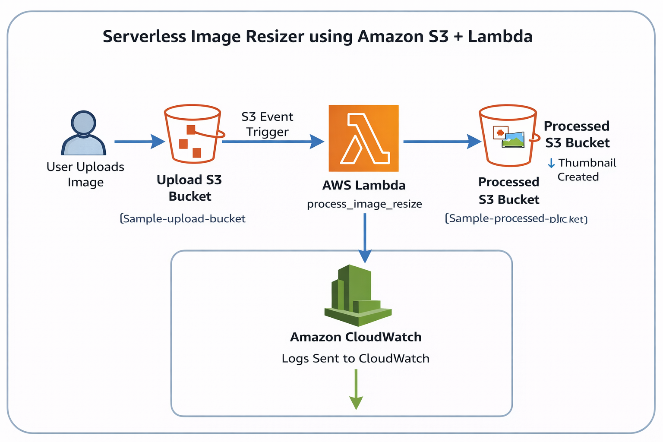
Step 1: Create S3 Upload Bucket
- Go to AWS Console
- Open S3 Service
- Click Create Bucket
- Bucket Name:
new-bucket7961

- Enable:
  - Versioning
  - Block Public Access
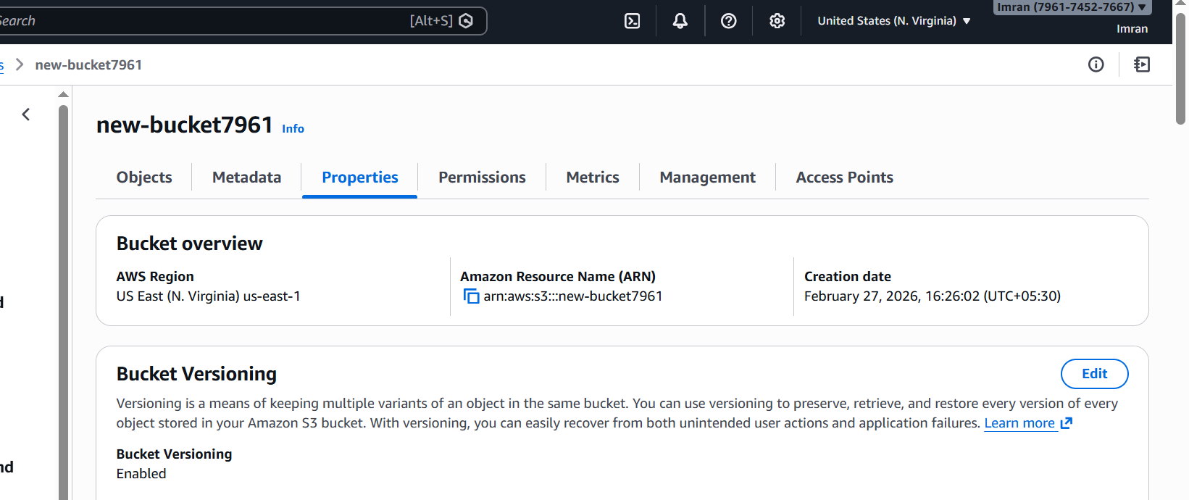
Step 2: Create S3 Thumbnail Bucket
- Click Create Bucket
- Bucket Name:
new-image-processed
- Enable:
  - Versioning
  - Block Public Access
- Click Create Bucket
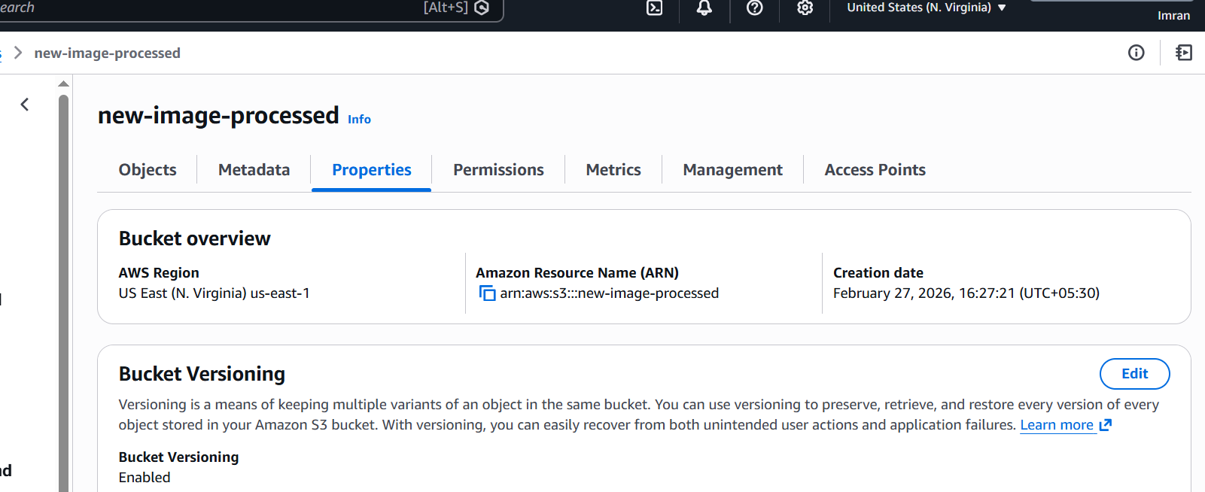
Step 3: Create Lambda Function
- Go to Lambda Service
- Click Create Function
- Select Author from Scratch
- Function Name:
new-function
- Runtime:
Python 3.11
- Create a new IAM Role
- Click Create Function
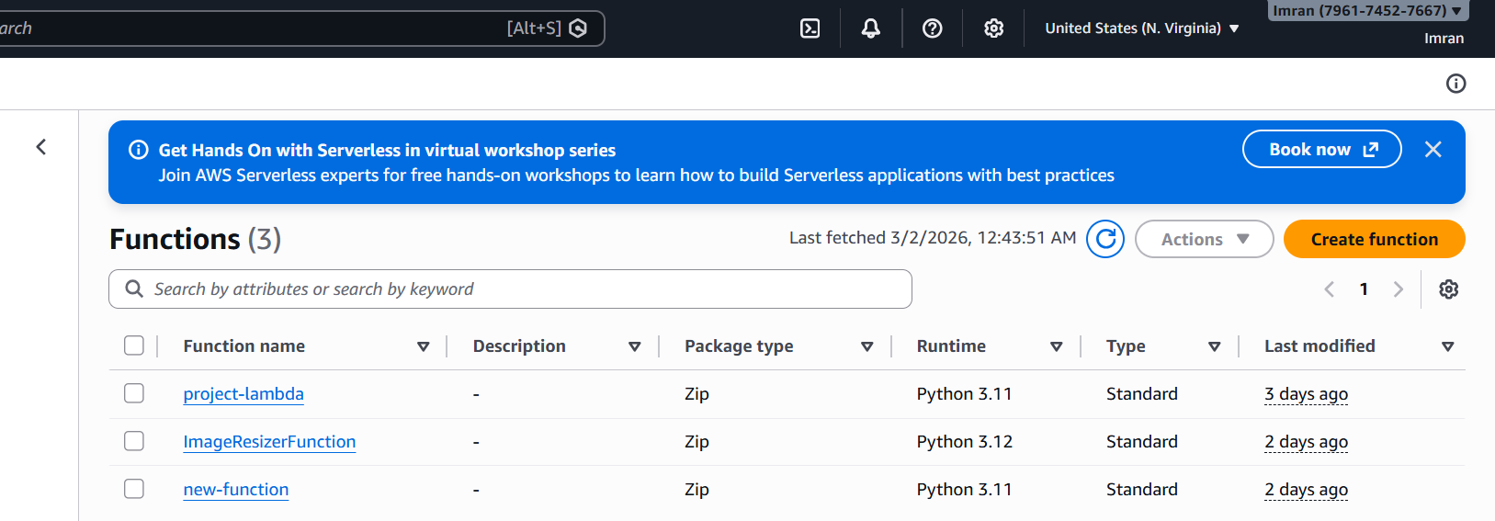
Step 4: Add Lambda Layer (Pillow Library)
- Download Pillow package
- Zip the library
- Go to Lambda Layers
- Click Create Layer
- Upload zip file
- Select Runtime: Python 3.11
- Add the layer to Lambda function
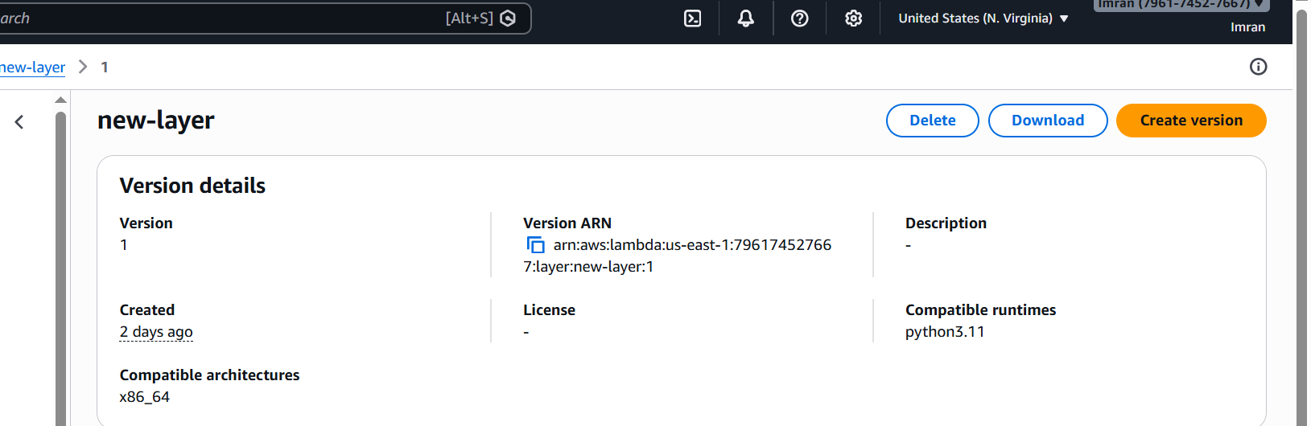
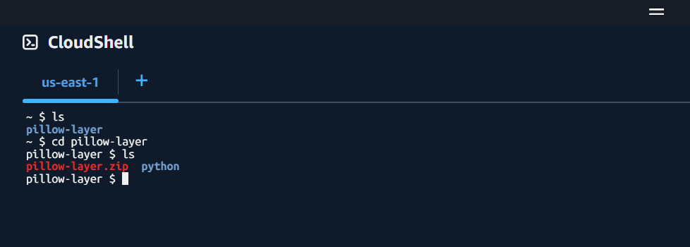
Step 5: Configure S3 Trigger
- Open Lambda Function
- Click Add Trigger
- Select S3
- Bucket:
new-bucket7961
- Event Type:
ObjectCreated (PUT)
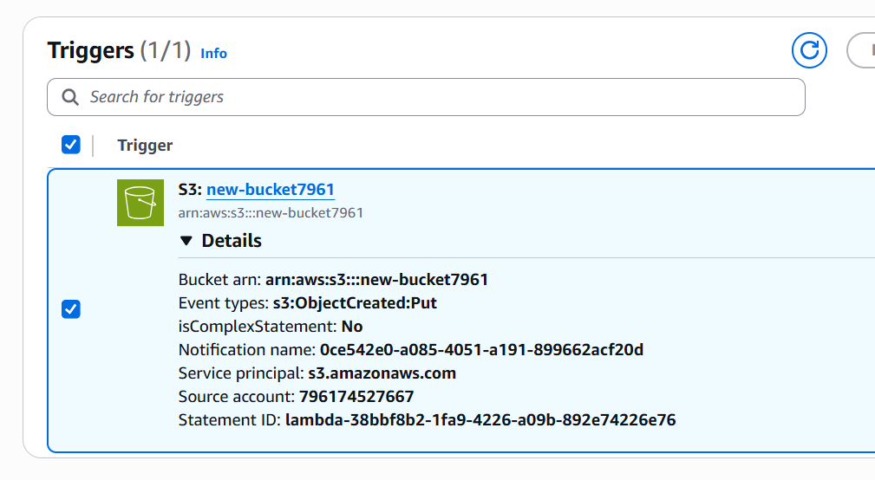
Step 6: Configure IAM Permissions
Lambda requires permissions to:
- Read from upload bucket
- Write to thumbnail bucket
- Write logs to CloudWatch
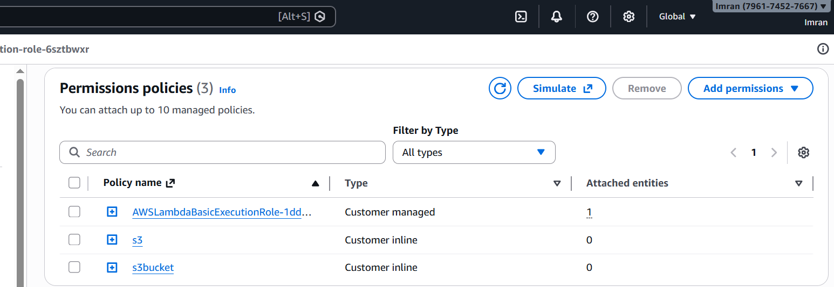
10. Lambda Function Code
import boto3
from PIL import Image
import io
import urllib.parse
s3 = boto3.client('s3')
DEST_BUCKET = "new-image-processed"
def lambda_handler(event, context):
print("EVENT RECEIVED:", event)
for record in event['Records']:
source_bucket = record['s3']['bucket']['name']
object_key = urllib.parse.unquote_plus(
record['s3']['object']['key']
)
print("Source bucket:", source_bucket)
print("Decoded object key:", object_key)
response = s3.get_object(
Bucket=source_bucket,
Key=object_key
)
file_content = response['Body'].read()
print("File fetched successfully")
image = Image.open(io.BytesIO(file_content))
image.thumbnail((150, 150))
# Fix RGBA error
if image.mode == "RGBA":
image = image.convert("RGB")
print("Image resized")
buffer = io.BytesIO()
image.save(buffer, format="JPEG")
buffer.seek(0)
resized_key = "resized-" + object_key.split(".")[0] + ".jpg"
s3.put_object(
Bucket=DEST_BUCKET,
Key=resized_key,
Body=buffer,
ContentType="image/jpeg"
)
print("Uploaded:", resized_key)
return "Done"
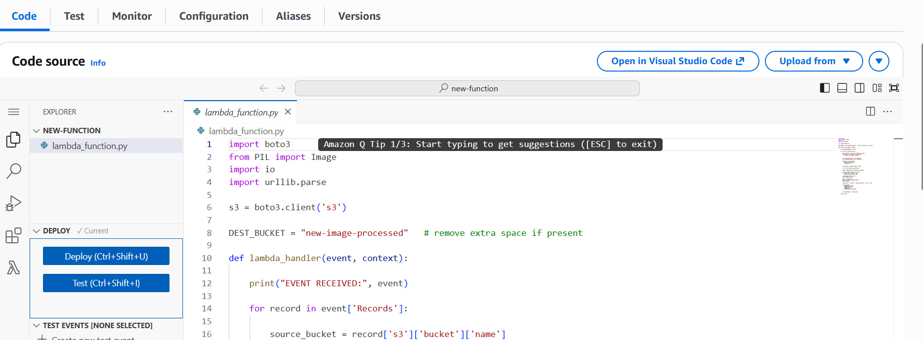
Testing the Application
- Upload a .jpg or .png image to the upload bucket.
- Lambda function automatically triggers.
- Image is resized to 150x150 pixels.
- Thumbnail stored in the destination bucket.
- Logs appear in CloudWatch.
Test Cases:
- Upload JPG → Thumbnail created
- Upload PNG → Thumbnail created
- Upload TXT → No processing
